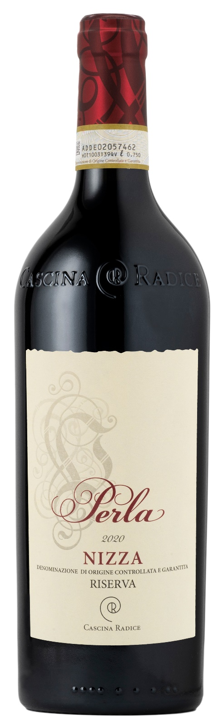
NIZZA DOCG RISERVA - PERLA
Just some towns in the Montferrat, historically suited to the cultivation and vinification of Barbera grapes, received Nizza DOCG title. Moreover, this privilege is only granted to vineyards with the best exposure and the harvest limit is set at a maximum of 7000 kg of grapes per hectare. These very strict rules along with responsible growing and a lot of love for the land gave birth to this wine.

Grape: Barbera 100%
Alc. Vol.%: 16
Vintage: 2020
Residual sugar g/l: 2
Total acidity g/l: 6,5
Region: Piedmont
Production zone: Vineyards in the area of Moasca (Province of Asti)
Capacity: 750ml

CHARACTERISTICS

Vinification: Traditional peel maceration for 12-14 days followed by fermentation in wood vat
Aging: 24 months in barrique, 6 months in bottle
Yield per ha: 7000kg
Colour: Intense red with shades of purple
Bouquet: Elegant, complex and ethereal with scents of wood berries and vanilla
Flavour: Enveloping, harmonic and full-bodied with a long-lasting finish

SERVING SUGGESTIONS

To be enjoyed with strong red meat dishes, game and noble poultry.
Serving temperature 18 °C, to be decanted.
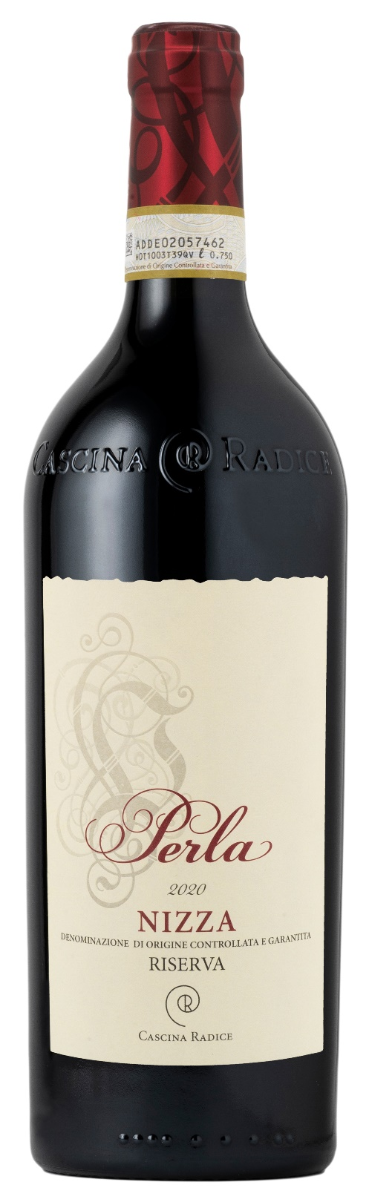
TECHNICAL INFORMATION / PALLETIZING

Size 750ml:
Article Nr. V02022A
GTIN-13 bottle 8017868005179
GTIN-13 carton N.A.
Closure Cork
Bottles / wooden case 6 bottles
Pallet size 80x120cm
Cases/layer 14
Cases/pallet 70
Kg/case+bottles 10,1
Kg/pallet 830

Contains sulphites
GMO Free
Revisione 01. 05.10.2026

